|  |  |  |
| --- | --- | --- |
| **Process** | **Steps To Execute** | **Expected Results** |
| Edit Return Action | 1. Navigate to Systems section, returns Option 2. Choose Returns Actions 3. Under action button of Refunded Action, choose Edit 4. Edit the name to new_refunded | Validate the presence of new_refunded in the table |

Solution:

Created one new java file as “ReturnPage.java”

package com.ibm.pages;

import java.io.FileInputStream;

import java.io.FileNotFoundException;

import java.io.IOException;

import java.util.Properties;

import org.openqa.selenium.WebDriver;

import org.openqa.selenium.WebElement;

import org.openqa.selenium.support.FindBy;

import org.openqa.selenium.support.PageFactory;

import org.openqa.selenium.support.ui.WebDriverWait;

public class ReturnPage {

WebDriver driver;

WebDriverWait wait;

public ReturnPage(WebDriver driver,WebDriverWait wait)

{

this.driver=driver;

this.wait=wait;

PageFactory.initElements(driver,this);

}

//WebElement for link System

@FindBy(xpath="//a[contains(text(),'System')]")

WebElement systemEle;

//WebElement for link Returns

@FindBy(xpath="(//a[contains(text(),'Returns')])[2]")

WebElement returnEle;

//WebElement for link Return Actions

@FindBy(xpath="//a[contains(text(),'Return Actions')]")

WebElement retactionEle;

//WebElement for button Action

@FindBy(xpath="(//button[contains(text(), 'Action')])[1]")

WebElement actionEle;

//WebElement for Edit

@FindBy(xpath="//a[@title='Edit']")

WebElement editEle;

//WebElement for field Return Action Name

@FindBy(xpath="//input[@name='name']")

WebElement retactnameEle;

//WebElement for icon Save

@FindBy(xpath="//button[@title='Save']")

WebElement saveEle;

public void clickOnLinkSystem()

{

systemEle.click();

}

public void clickOnLinkReturns()

{

returnEle.click();

}

public void clickOnLinkRetActions()

{

retactionEle.click();

}

public void clickOnAction()

{

actionEle.click();

}

public void clickOnEdit()

{

editEle.click();

}

public void enterReturnActionName(String returnactionname)

{

retactnameEle.clear();

retactnameEle.sendKeys(returnactionname);

}

public void clickOnIconSave()

{

saveEle.click();

}

public void validationOnRecord() throws FileNotFoundException, IOException

{

Properties p = new Properties();

p.load(new FileInputStream("./TestData/magentodata.properties"));

String pagesource = driver.getPageSource();

//System.out.println(pagesource);

if(pagesource.contains(p.getProperty("returnactionname"))) {

System.out.println("The presence of edited action name is confirmed!");

}

else {

System.out.println("The action is not added to the Return Actions List");

}

}

}

Modified existing files “BaseTest.java” and “magnetodata.properties”

package com.ibm.test;

import java.io.IOException;

import java.util.HashMap;

import java.util.concurrent.TimeUnit;

import org.openqa.selenium.WebDriver;

import org.openqa.selenium.chrome.ChromeDriver;

import org.openqa.selenium.support.ui.WebDriverWait;

import org.testng.annotations.Test;

import com.ibm.pages.AdminPage;

import com.ibm.pages.BannerPage;

import com.ibm.pages.CouponPage;

import com.ibm.pages.LoginPage;

import com.ibm.pages.ProductPage;

import com.ibm.pages.ReturnPage;

import com.ibm.utilities.PropertiesFileHandler;

public class BaseTest {

@Test

public void login() throws IOException, InterruptedException

{

String file="./TestData/magentodata.properties";

PropertiesFileHandler propFileHandler = new PropertiesFileHandler();

HashMap<String, String> data= propFileHandler.getPropertiesAsMap(file);

String url = data.get("url");

String email = data.get("email");

String password = data.get("password");

/*String expectedTitle = data.get("expectedtitle");

String couponname = data.get("couponname");

String code = data.get("code");

String discount = data.get("discount");

String amount = data.get("amount");

String startdate = data.get("startdate");

String enddate = data.get("enddate");

String usespercoupon = data.get("usespercoupon");

String usespercustomer = data.get("usespercustomer");

String expectedcouponmessage = data.get("expectedcouponmessage");

String productname = data.get("productname");

String metatitle = data.get("metatitle");

String model = data.get("model");

String gst = data.get("gst");

String price = data.get("price");

String specialdiscount = data.get("specialdiscount");

String discountprice = data.get("discountprice");

String imagepath = data.get("imagepath");*/

String returnactionname = data.get("returnactionname");

System.setProperty("webdriver.chrome.driver", "./drivers/chromedriver.exe");

WebDriver driver = new ChromeDriver();

WebDriverWait wait=new WebDriverWait(driver, 60);

driver.manage().window().maximize();

driver.manage().timeouts().implicitlyWait(30,TimeUnit.SECONDS);

driver.get(url);

LoginPage login = new LoginPage(driver);

login.enterEmailAddress(email);

login.enterPassword(password);

login.clickOnLogin();

/*AdminPage apage=new AdminPage(driver, wait);

String actualTitle=apage.getCurrentTitle();

if(actualTitle.equals(expectedTitle))

{

System.out.println("Test Passed");

propFileHandler.setKeyAndValue(file, "TestResult", "Test Passed");

}

else

{

System.out.println("Test failed");

propFileHandler.setKeyAndValue(file, "TestResult", "Test Failed");

}*/

/*BannerPage bpage=new BannerPage(driver, wait);

bpage.addBanner();*/

/*CouponPage coupon = new CouponPage(driver);

coupon.clickOnLinkMarketing();

coupon.clickOnLinkCoupons();

coupon.clickOnIconAddNew();

coupon.enterCode(code);

coupon.clickOnType();

coupon.enterDiscount(discount);

coupon.enterAmount(amount);

coupon.enterStartDate(startdate);

coupon.enterEndDate(enddate);

coupon.enterUsesPerCoupon(usespercoupon);

coupon.enterUsesPerCustomer(usespercustomer);

coupon.clickOnStatus();

coupon.enterCouponName(couponname);

coupon.clickOnIconSave();

Thread.sleep(5000);

coupon.validationOnRecord();*/

/*ProductPage pp = new ProductPage(driver, wait);

pp.clickLinkCatalog();

pp.clickOnLinkProducts();

pp.clickOnIconAddNew();

pp.enterMetaTitle(metatitle);

pp.enterProductName(productname);

pp.clickOnTabData();

pp.enterModel(model);

pp.enterGST(gst);

pp.enterPrice(price);

pp.enterSplDiscount(specialdiscount);

//pp.enterDiscountPrice(discountprice);

pp.clickOnTabLink();

pp.selectFromTabs();

pp.selectCategories();

pp.clickOnTabImage();

pp.enterImage(imagepath);

pp.clickOnIconSave();

Thread.sleep(5000);

pp.validationOnRecord();*/

ReturnPage rp = new ReturnPage(driver, wait);

rp.clickOnLinkSystem();

rp.clickOnLinkReturns();

Thread.sleep(2000);

rp.clickOnLinkRetActions();

rp.clickOnAction();

rp.clickOnEdit();

rp.enterReturnActionName(returnactionname);

rp.clickOnIconSave();

Thread.sleep(4000);

rp.validationOnRecord();

// apage.clickOnLogOut();

// driver.close();

//excel data using dataprovider

//run and check

//sends data in excel one by one

/*@Test(dataProvider = "data")

public void testcase2(String user, String pwd){

System.out.println(user);

System.out.println(pwd);

}

@DataProvider(name="data")

public Object[][] data() throws IOException {

return ExcelUtil.DataTable("./TestData/TestData.xlsx","LoginData");

}*/

}

}

#Test Result

#Sat Dec 15 00:18:38 IST 2018

discountprice=950

productname=Product_Rajendra

code=ABC123

password=456789

couponname=Coupon_Rajendra

discount=15

model=Model_Rajendra

metatitle=MetaTitle_Rajendra

imagepath=C\:\\Users\\IBM_ADMIN\\Documents\\Training\\Selenium\\Proj Day1\\SeleniumFramework\\TestData\\banner.jpg

url=http\://atozgroceries.com/admin/

TestResult=Test Passed

usespercoupon=1

amount=1000

expectedbannermessage=Success\: You have successfully added banner\!

enddate=12/30/2018

email=demo@atozgroceries.com

gst=8

usespercustomer=1

price=100

bannername=Banner_Rajendra

specialdiscount=5

sortorder=1

expectedcouponmessage=Success\: You have successfully added new coupon\!

startdate=12/20/2018

expectedtitle=Dashboard | Admin Panel - Powered By A&S

returnactionname=new_refunded

After executing BaseTest.java file, the console result as below:

[RemoteTestNG] detected TestNG version 6.14.3

Starting ChromeDriver 2.44.609538 (b655c5a60b0b544917107a59d4153d4bf78e1b90) on port 20786

Only local connections are allowed.

Dec 16, 2018 11:41:33 PM org.openqa.selenium.remote.ProtocolHandshake createSession

INFO: Detected dialect: OSS

The presence of edited action name is confirmed!

PASSED: login

===============================================

Default test

Tests run: 1, Failures: 0, Skips: 0

===============================================

===============================================

Default suite

Total tests run: 1, Failures: 0, Skips: 0

===============================================

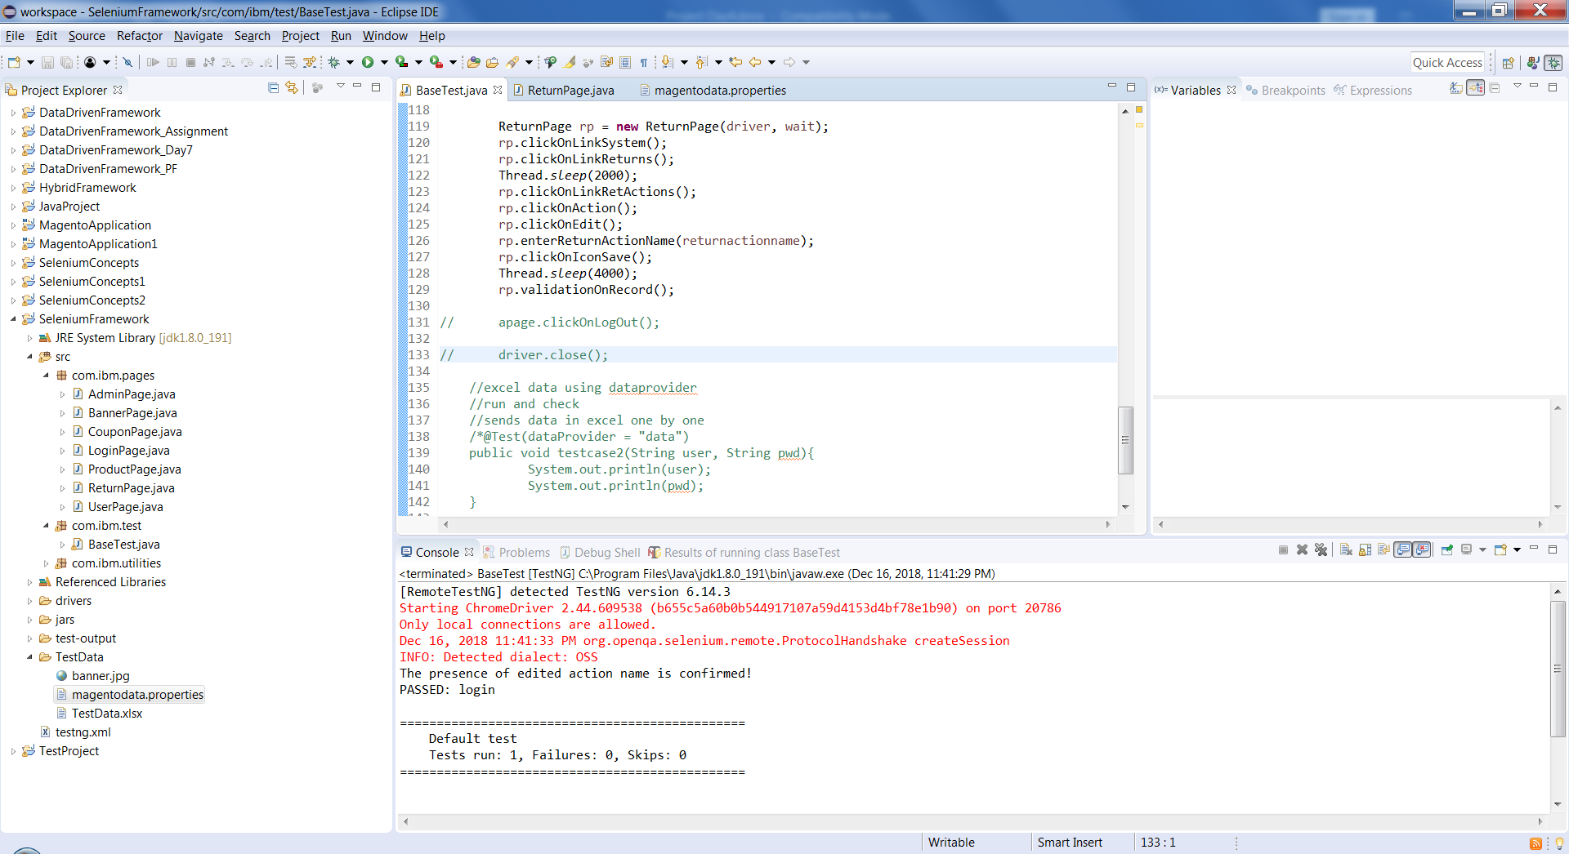

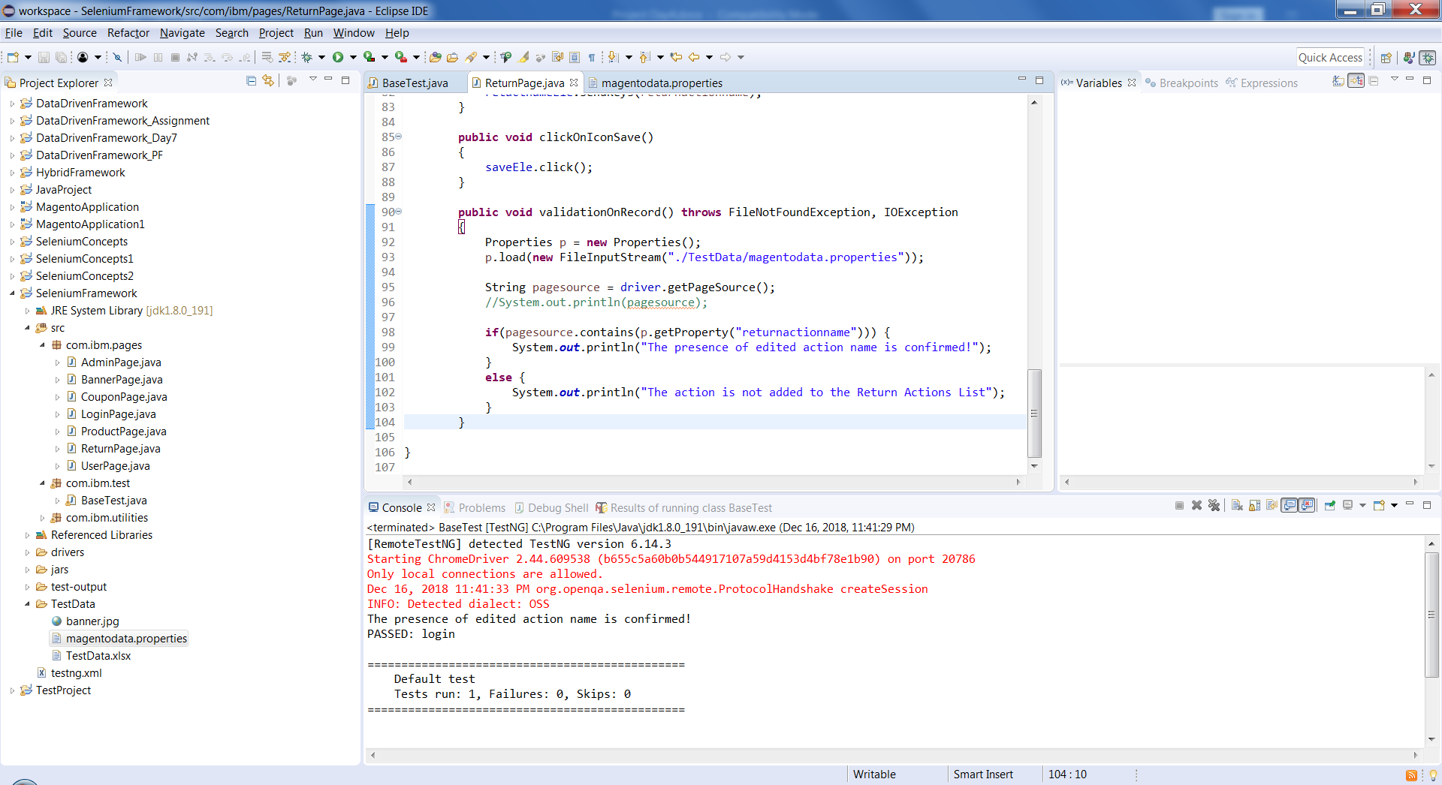

The output on Chrome browser:

